SQL LAB 4

Lab 2 : Use Database StudentManagementSystem and student table

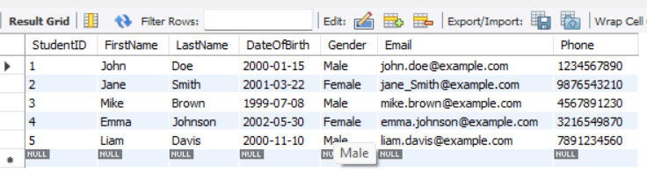

1.Task: Let's consider a scenario where you want to retrieve information about students from a database table named student and display the results in ascending order based on their last names. Hint: Use orderBy clause in a ascending Order

SELECT \* FROM Student

ORDER BY LastName ASC;

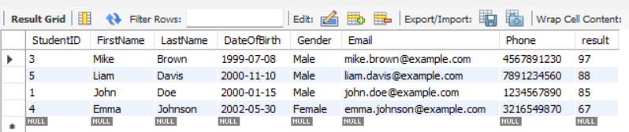

2.Lab 2- Database Schema: Use the same database scheme created in Previous Lab. Task: Let's consider a scenario where you want to count the number of students based on their gender from a database table named Student. Hint: use GroupBy clause and Count() function

SELECT Gender, COUNT(\*) AS TotalStudents FROM Student GROUP BY Gender;

